
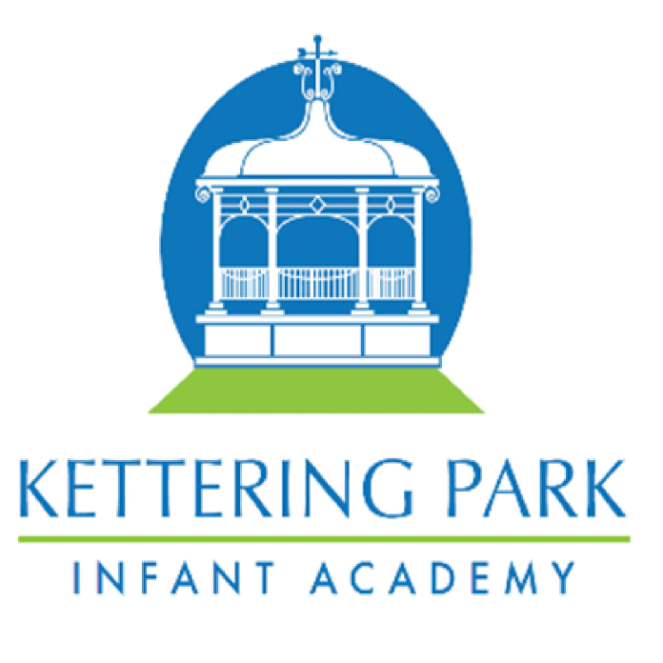
Geography Unit Year Map

 | Term 1 | Term 2 | Term 3 | Term 4 | Term 5 | Term 6
EYFS | Local Area – features of the park |  | Comparing Locality (Farm and town)  India |  | Comparing Environments – Land and Sea
Year 1 |  | What is it like here? |  | What is the weather like in the UK? |  | What is it like to live in Shanghai?
Year 2 |  | Would you prefer to live in a hot or cold place? |  | Why is our World wonderful? |  | What is it like to live by the coast?
Year 3 | Are all settlements the same? |  | Who lives in Antarctica? |  | Why do people live near volcanoes?
Year 4 | Why are rainforests important? |  |  | Where does our food come from? |  | What are rivers and how are they used?
Year 5 | What is life like in the Alps? |  | Why do oceans matter? |  | Why does population change?
Year 6 |  | Would you like to live in desert? |  | Where does our energy come from? |  | Can I carry out an independent fieldwork enquiry?

