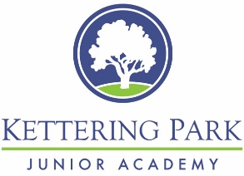
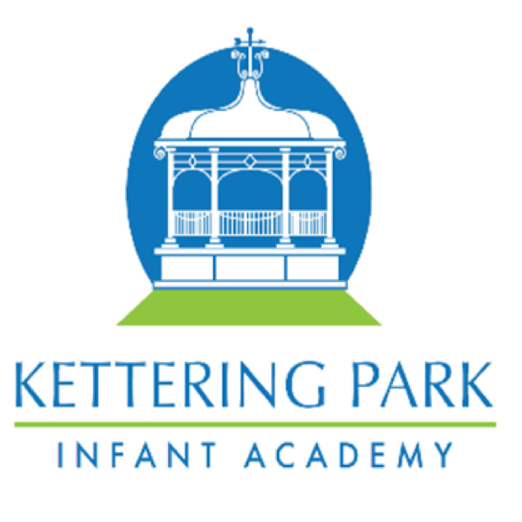
History Unit Year Map

 | Autumn |  | Spring |  | Summer
EYFS | Changes within living memory – families & growing up |  | Comparing objects from the past |  | Kings and Queens – linking to story characters
Year 1 | How Am I Making History? |  | How Have Toys Changed? |  | How Have Explorers Changed the World?
Year 2 | How Was School Different in the Past? |  | How Did We Learn to Fly? |  | What is a Monarch?
Year 3 |  | Would you prefer to live in the Stone Age, Bronze Age or Iron Age? |  | How have children's lives changed? |  | Why did the Romans settle in Britain?
Year 4 |  | How hard was it to invade and settle in Britain? | Were the Vikings raiders, traders or settlers? |  | What did the ancient Egyptians believe?
Year 5 |  | What was life like in Tudor England? |  | What did the Greeks ever do for us? |  | What does the census tell us about our local area?
Year 6 | How did the Maya civilisation compare to the  Anglo-Saxons? |  | What was the impact of World  War II on the people of Britain? |  | British Black History – enquiry question?

