




Positive Relationships and Behaviour Policy
Academy Policy

Document Title | Positive Relationships and Behaviour Policy
Approved by: | KPIA / KPJA Governing Body
Approval Date: | September 2025
Review Frequency: | Annually
Review Date: | September 2026

This policy is written in conjunction with Kettering Park Infant Academy

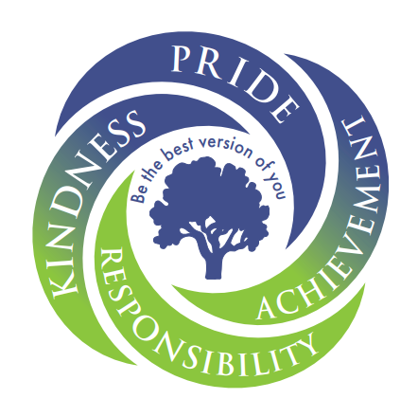
KPIA Values and Ethos KPJA Values and Ethos
We share the joint mission statement with InMat of ‘Children First’. Our vision encompasses this further through:
We are …
Kind
Proud
Independent
Achieving

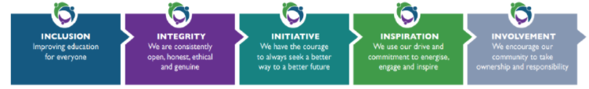
Together Honesty Independence Believe Teamwork

School Rules

At Kettering Park Infant and Junior Academies we take full responsibility for ourselves, our learning and our behaviour.

We will:
- Listen to all members of the school community and treat them respectfully.
- Work our hardest in every lesson.
- Treat school property respectfully.
- Move around the school in a calm and safe manner.
- Never resort to aggressive behaviour.

Learning Behaviours at Kettering Park Junior Academy (see appendix)
In addition to our whole school learning behaviours, we encourage children to take responsibility by creating a class charter at the beginning of each academic year which is their agreed classroom expectations.
What we want to achieve:
The happiness and the wellbeing of our pupils underpins everything that we do here at Kettering Park Infant and Juniors. We know that when children feel happy, safe, listened to and respected then they will make greater progress in their learning. We want to ensure a clear, fair and consistent approach to dealing with any behavioural concerns that arise throughout the primary phase. We believe that all pupils should be treated equally and taught the following skills:

- How to maintain positive relationships with peers and adults
- How to maintain a positive outlook
- How to use strategies to regulate their own emotions and recognise the emotions of others
- To have positive learning behaviour strategies which allow them and others to make academic progress.

We understand that all behaviour is a form of communication, and that it is important to dedicate planned opportunities to supporting emotional literacy, problem solving skills and social wellbeing of all our pupils. Children will be taught, through or PSHE lessons strategies to support wellbeing and happiness. All of our staff will teach and model expected behaviours, respect and empathy in order to learn and function at school and life beyond school. We follow the Six Principles of Nurture to further support our learning behaviours and expectations.

Our policy statement:

- Kettering Park Infant and Juniors work collaboratively and in partnership with other schools as part of the Inspire Multi Academy Trust (InMAT).
- Our behaviour policy is written in collaboration across KPIA and JPJA to ensure consistency and continuity for pupils.
- As a Multi Academy Trust our schools have individual responsibility to ensure all pupils behave in an appropriate manner in line with the school’s positive approach to behaviour and attitudes. We require everyone to show respect, tolerance and understanding towards others, and through self-discipline and consideration of all, behave in a sensible and civilised fashion.
- Statutory guidelines exist to ensure that monitoring records of serious behavioural related incidents are kept in school and reviewed on a regular basis. These are shared with the Local Academy Committee (LAC) and Trust as required.

Responsibilities
All Staff are responsible for:

- Implementing the behaviour policy consistently.
- Always setting high expectations for behaviour at all times.
- Promoting positive attitudes towards behaviour.
- Liaising with parents/carers and external agencies where appropriate.
- Modelling positive behaviour and respect at all times.
- Providing a personalised approach to the specific behavioural needs of individual pupils – adapting and providing reasonable adjustments where required.
- Recording behaviour incidents using Arbor/MyConcern.

The senior leadership team will support staff in responding to behaviour incidents. They will also ensure that the policy and the underpinning principles are upheld. SLT will constantly monitor behaviour of all pupils.

Parents are expected to:

- Support their child in adhering to the pupil code of conduct.
- Adhere to the parent code of conduct.
- Inform the school of any changes in circumstances that may affect their child’s behaviour.
- Discuss any behavioural concerns with the class teacher promptly.
- Discuss, share and reinforce the school’s behavioural expectations to ensure positive behaviour expectations are reinforced and praised.

Pupils are expected to:
- Abide by all school rules and values.
- Behave in an orderly and self-controlled way.
- Show respect to all members of the school community.
- In class, make it possible for all pupils to learn. Pupils are responsible for their own learning.
- Move quietly around the school.
- Treat the school buildings and school property with respect.
- Wear the correct uniform at all times.
- Accept sanctions when given.
- Demonstrate and praise positive learning behaviours.

This policy is applicable to:
- All members of staff (including supply and part time).
- All pupils.
- All extended curriculum providers who make additional contributions to children’s learning on or off site.
- All external agencies that contribute their professional knowledge and expertise to supporting our pupils in challenging or vulnerable circumstances.

Behaviour Management
At Kettering Park Infants and Juniors we take pride in ourselves, our students and our values and ethos are shown in every aspect of school life. As such, our approach to unacceptable behaviour is restorative and will enable students to:
- show respect to each other’s viewpoints,
- take responsibility for their behaviour,
- reflect on ways to repair harm and ensure behaviours are not repeated.
In regards to the restorative approach, specific questioning will be used to support and repair:
- What happened? Drawing on each person’s story one at a time and talking together to resolve
- What were you thinking/feeling? Sharing their emotions using Zones of Regulation at the time of the incident.
- What do you think/feel about it now? Sharing emotions using Zones of Regulation after the incident.
- Who has been affected and how? Thinking about how their actions have affected others.
- What needs to happen to put it right? Discuss consequences and steps to resolve.
- What do you/they need to do differently next time? Ensure all children are happy that the situation has been resolved and how to avoid further incidents.
Creating a Climate for Positive Behaviour and Positive Praise
We believe that the best way to achieve a positive learning culture is to recognise and manage behaviour positively - providing students with the opportunity to take responsibility for their own behaviour. Therefore, we ensure that we are continually reinforcing the positive learning behaviours outlined in our school values and behaviour expectations and catch children making positive decisions. This will take the form of positive praise.
The use of praise and positive encouragement is to be used to promote the correct behaviours. Children are given praise on an individual and group basis through:
- Non – verbal (smiles, thumbs up, etc.) and verbal praise
- Positive and constructive feedback on work
- Stickers
- Celebration assembly/ Star of the week/InMAT values
- Post cards home
- Class Dojo rewards
All the children who attend Kettering Park Infants or Juniors will feel wanted and that they, as individuals, contribute to school life, this is supported by the PSHE/RSE/No Outsiders Curriculum.
Creating the right atmosphere in school arises from good inter-personal relationships. Parents, guardians, visitors, governors, teachers and children must treat each other with a level of mutual respect. Staff greet students and expect to be greeted in return.

Promoting and Reinforcing Outstanding Behaviour
- All staff visibly promoting positive behaviour and ensuring behaviour systems are being followed. A member of SLT will always be available, on duty at lunch times.
- Where appropriate we praise in public.
- Behavioural discussions with a child should be carried out away from the whole class, this is the expectation for all members of staff.
- Students PARK walk around the school – this means that they should walk with good Posture, Arms relaxed at their side, Respectful of others and should Keep walking, keep left so they do not cause a blockage.
- Classes are escorted to break and lunch by the class teacher, support staff, cover or Midday supervisor.
- At the end of breaks and lunchtime, we use a two-whistle system to line up safely and calmly. On the first whistle children freeze and on the second children move to their lines calmly and quietly.
- Adults in the school will speak positively and with respect to pupils. Adults in school will not shout – reactions to negative behaviour should be non-emotional, limiting attention on the child. Discussions about behaviour and the delivery of sanctions/consequences should be given in private. Time should be taken to ‘fix’ the situation if appropriate and relationships restored, following the restorative approach.
- Adults in the school will not refer to behaviour in a derogatory manner (children’s behaviour is never referred to as ‘disgusting’ or ‘terrible’).
- Following a restorative conversation addressing behaviour incidents consequences are provided by the adult dealing with the incident unless it is escalated to SLT where they will continue to deal with the incident and action any consequences.
- Teaching staff will be punctual to lessons and to collect pupils at designated times.
- Classes may have a seating plan that is adapted to the needs of the class and the lesson.
- Use a lining up order at all times. Adults will ensure that children enter and exit classrooms quietly in line. Children will always use their line order – usually alphabetical but may have adjustments.
- Adults will apologise if they make a mistake or jump to conclusions. It is important to model that mistakes are normal and that we all take responsibility for our actions.
- Adults will always focus on redirecting behaviour back to learning – rather than focusing on inappropriate behaviour.
- Polite, calm language and tone will be used at all times by adults.
- Adults will use ‘we’ when discussing expectations, for example: ‘At Kettering Park, we expect …’
- Adults will use ‘if’ and ‘then’ to clarify actions and consequences: ‘If you throw a pencil, you will then miss your play’.
- Teachers should model behaviour and teach it explicitly where needed.
- A bell will be used to gain the attention of the children.
- All staff carry dojo tokens which can be given to children demonstrating the academy values.

Managing low level disruption and unacceptable behaviour
In situations where the school rules, learning behaviours and values are not being practised, staff will follow a number of steps to support the pupil in realising the correct behaviours.
Red card behaviour incidents are recorded on MyConcern to ensure the correct support is in place for all involved this will include an initial incident as well as repeated incidents so that SLT can closely monitor and provide the appropriate support for the individual.
If redirection and positive encouragement do not work, staff will use the Warning/ Steps system (See Appendix 2)
After using these steps there must be an opportunity for a discussion to be held with the child about their behaviour. This needs to be completed immediately in order for the child to move forward. Conversations linked to the restorative approach will be used (see policy for suggestions).
The warning system is cumulative but it should begin again for each new incident. Warnings should not be held over children for more than one teaching session.
If a member of staff is in any doubt about the best way to proceed or feels that the situation is not best dealt with in line with the model outlined then they should consult with a member of SLT or wellbeing and pastoral lead outlining their reasons for taking a different approach. Any different approach should be agreed before action is taken. Decisions about behaviour should always be made with the best interests of all children at centre of them. Staff may also need to consult the school SENCO for Pupils with additional needs or with Special Educational needs in order to implement agreed reasonable adjustments.
Significant/ serious behaviour concerns
Some behaviour is of sufficient seriousness that it will be dealt with by a senior leader and no warnings will be given. Consequences and sanctions will be decided depending on context, individual cases and context, feedback will be given back to the class teacher on these. These behaviours may include:
- Physical aggression
- Verbal assault
- Threatening behaviour
- Extreme rudeness
- Extreme disruption
- Damaging property
- Persistent refusal
- Racist or homophobic comments
- Extreme inappropriate language
SOS
We use the red SOS card or a verbal SOS on the two way radio distributed to classes and individual staff members to support teachers and other members of staff with significant/serious behaviour concerns. If a child has not responded to reminders/warning steps, being persistently disruptive or has engaged in a serious misbehaviour outlined above, an SOS will be sent to the office to request assistance. A member of SLT, or the wellbeing and pastoral lead will attend to support the situation.

Off-site behaviour
Sanctions may be applied where a pupil has misbehaved off-site when representing the school, such as on a school trip. The decision to act will be made at the discretion of the head teacher.

Suspensions
Please also refer to the InMAT Suspension policy available on the KPJA Website
On rare occasions the head teacher may feel that a formal process should be activated to remove the child from the school temporarily. Such suspensions are an extreme step and will only take place when long term misbehaviour is not improving as a result of the above strategies and learning of others is seriously hindered. Very occasionally, an incident may be serious enough to warrant an immediate suspension, these include the following:
- The use of racial or homophobic language where the child is aware of its meaning and impact
- Causing another child significant harm (including emotional, physical, social, racist, sexual, verbal or cyber)
- Physically assaulting a member of staff.
- Causing permanent damage to the school building and property.
(The above is not an exhaustive list of incidents)
When an incident of extreme seriousness has occurred, all parties need a short period to consider the best course of action.
At the time of suspension, the pupil and parent will be invited to a reintegration meeting, on the child’s return, where criteria will be set down between the head teacher, parent and pupil in order that they can return to school successfully.
In the event of an exclusion both schools will follow the guidelines set out by the government: https://www.gov.uk/school-discipline-exclusions/exclusions

Pupil Support and Inclusion
The school recognises its legal duty under the Equality Act 2010 to prevent pupils with a protected characteristic from being at a disadvantage. Consequently, our approach to challenging behaviour may be adapted to facilitate the needs of an individual pupil.

The school’s Special Educational Needs Co-ordinator and/or Wellbeing and Pastoral lead will evaluate a pupil who exhibits challenging behaviour to determine whether they have any underlying needs that are not currently being met.
Where necessary, support and advice will also be sought from specialist teachers, an educational psychologist, outreach provider, medical practitioners and/or others, to identify or support specific needs.
When acute needs are identified in a pupil, we will liaise with external agencies and plan support programmes for that child. We will work with parents to create the plan and review it on a regular basis.
As part of our inclusive practice we acknowledge that there may be extenuating factors that need to be taken into account when working restoratively. Whilst we will never condone inappropriate behaviour, we will consider all extenuating factors to ensure any sanctions are fair and appropriate and reasonable adjustments are made.
The use of reasonable force
The term ‘reasonable force’ covers a broad range of actions used by most teachers at some point in their career that involves a degree of physical contact with pupils.
- ‘Reasonable in the circumstances’ means using no more force than is needed.
- Control means whether passive or physical contact, such as standing between pupils or blocking a pupil’s path, or active physical contact such as leading a pupil by the arm out of a classroom.
- Restraint means to hold back physically or bring a pupil under control. It is typically used in more extreme circumstances, for example when two pupils are fighting and refuse to separate without physical intervention.
Who can use reasonable force?
- All members of staff have the legal power to use reasonable force
- This power applies to any member of staff at the school. It can also apply to people whom the head teacher has temporarily put in charge of pupils, such as unpaid volunteers.
When can reasonable force be used?
In some circumstances, staff may use reasonable force to restrain a pupil to prevent them:
- Causing disorder
- Hurting themselves or others
- Damaging property

Incidents of reasonable force must:
- Always be used as a last resort – if all other de-escalation techniques have failed.
- Be applied using the minimum amount of force and for the minimum amount of time possible
- Be used in a way that maintains the safety and dignity of all concerned
- Never be used as a form of punishment
- Be recorded and reported to parents

Key members of staff have Team Teach training and they should be called upon, where possible, in the event of a child needing reasonable force. However, this may not always be feasible in all situations.

All incidents involving the need to restrain a child will be logged and passed onto the safeguarding team. A bound and numbered book is kept and signed/checked by designated LAC member.

Physical handling plans are in place for identified children where necessary and these are signed by parents/carers and all adults working with the child within the school.

Lunchtime behaviour

When there is negative behaviour during lunchtimes the following procedures will apply:

If the behaviour is low level, such as running when not supposed to, then the warning system (steps) will be used in the same way as the classroom. Midday supervisors should give a positive verbal reminder of expected behaviour. Where behaviour does not improve, they should show the yellow card and make a note of the child’s name in their book. After 5 minutes, they should decide whether the name can be crossed out if behaviour has improved or whether to use a red card and deliver a consequence. Consequences include removal of playground equipment, time at the regulation station or bringing children off of the playground to the member of SLT on duty.

Managing serious incidents in the classroom/ playground

If a serious incident occurs in the playground, such as a fight or a child who is dysregulated:

- Send a child to the school office with an SOS card – the office will immediately contact a member of SLT.
- Remove other children calmly to a safe area
- Speak calmly and with authority to the child/ren in need:

- STOP
- I CAN SEE YOU ARE _____
- LET ME HELP YOU
- FOLLOW ME

Repeat this sequence to calm the situation. Particularly the last 3 statements until a member of SLT arrives.

Confiscation
Any prohibited or illegal items found in pupils’ possession will be confiscated. Items prohibited by the school will be returned to parents. Illegal items will be referred to the school’s designated safeguarding lead.
We will also confiscate any item which is harmful or detrimental to school discipline. These items will be returned to pupils after discussion with senior leaders and parents, if appropriate.
Searching and pupils is conducted in line with the DfE’s latest guidance on searching, screening and confiscation. School staff can search for any item if the pupil consents. If a pupil does not consent, a member of the Senior Leadership Team will be contacted. We recommend that all searches are carried out with another member of staff.
Child-on-Child Abuse
Child-on-child abuse occurs when a young person is exploited, bullied and/or harmed by their peers who are the same or similar age; everyone directly involved in child-on-child abuse is under the age of 18. ‘Child-on-Child abuse can relate to various forms of abuse (not just sexual abuse and exploitation), and crucially it does not capture the fact that the behaviour in question is harmful to the child perpetrator as well as the victim.
Where there has been a report of sexual violence, the DSL (or a deputy) should make an immediate risk and needs assessment, considering:
· The victim, especially their protection and support
· The alleged perpetrator
· All other children at the school (and adult students and staff, if appropriate), especially any actions
that are appropriate to protect them.

Where there has been a report of sexual harassment, the need for a risk assessment should be considered on a case-by-case basis. Risk assessments should be recorded and kept under review. The DSL (or a deputy) should engage with children's social care and specialist services as required. Where there has been a report of sexual violence, it's likely that professional risk assessments by social workers or sexual violence specialists will be required. The DSL (or deputy) should use these assessments to inform the school's approach and to update our own risk assessment.

Malicious Allegations

Where a pupil makes an accusation against a member of staff and that accusation is shown to have been malicious, the head teacher will discipline the pupil in accordance with this policy.
Please refer to our Safeguarding and Child Protection Policy for more information on responding to allegations of abuse which can be found on our website.
The head teacher will also consider the pastoral needs of staff accused of misconduct.
Transition
To ensure a smooth transition to the next year, pupils have transition sessions with their new teacher(s). In addition, staff members hold transition meetings.
To ensure behaviour is continually monitored and the right support is in place, information related to pupil behaviour issues may be transferred to relevant staff at the start of the term or year. Information on behaviour issues may also be shared with new settings for those pupils transferring to other schools.
Individuals with specific needs for transition will be considered on a case-by-case basis by the inclusion team and specific child-led support will be put in place.
Additional opportunities will also be planned for, between KPIA and KPJA to ensure that there is a smooth transition between KS1 and KS2 and between KS2 and KS3.
Training
Our staff are provided with training on managing behaviour, as part of their induction process.
Behaviour management will also form part of continuing professional development.
Identified staff will be trained in the proper use of de-escalation strategies and in guiding a child to a safe place when are they are dysregulated.

Local Academy Committee
It is the responsibility of the LAC to monitor exclusions, bullying and racist incidents. They will also ensure that this policy is administered fairly and consistently. The head teacher will report to the LAC on a termly basis.

Monitoring arrangements
This behaviour policy rationale will be reviewed by the head teacher and LAC annually. At each review, the policy will be approved by the head teacher and LAC.
Appendices
- Legalisation and statutory requirements
- Learning behaviours
- Behaviour Steps
- Midday Supervisor Steps
- Report card
- Behaviour/ Pastoral Support plan
- Dojo and Rewards
- Principles of Nurture
- Example of Zones of Regulation
- Behaviour yellow/red cards

Appendix 1.
Legislation and statutory requirements
- This policy is based on advice from the Department for Education (DfE) on:
- Behaviour and discipline in schools
- Searching, screening and confiscation at school
- The Equality Act 2010
- Use of reasonable force in schools
- Supporting pupils with medical conditions at school
- It is also based on the special educational needs and disability (SEND) code of practice.
- In addition, this policy is based on:
- Schedule 1 of the Education (Independent School Standards) Regulations 2014; paragraph 7 outlines a school’s duty to safeguard and promote the welfare of children, paragraph 9 requires the school to have a written behaviour policy and paragraph 10 requires the school to have an anti-bullying strategy
- DfE guidance explaining that academies should publish their behaviour policy and anti-bullying strategy online

Appendix 2 Learning behaviours:
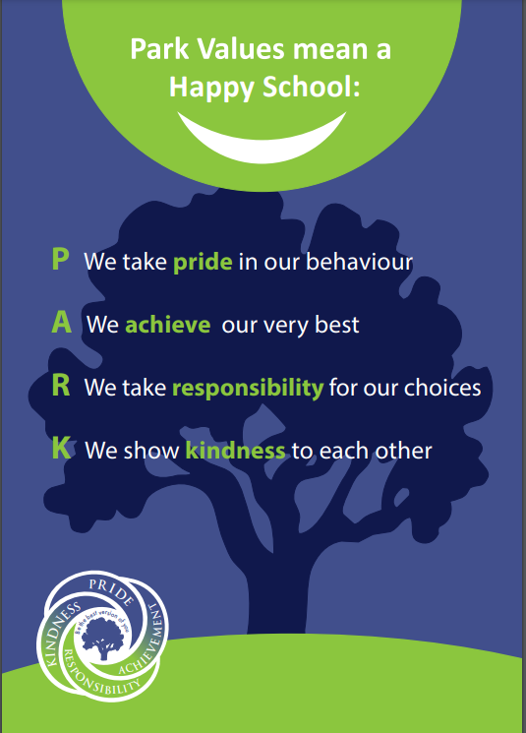

Appendix 3: Class Based Behaviour Steps for KPJA:
If redirection and positive encouragement do not work, staff will use the Warning System explained below:
Step 1
Verbal reminder of the expected behaviour referring to our PARK values and Class charter e.g. ‘This is a reminder that we face the front and listen. Thank you.’ (Could be non-verbal if deemed appropriate at this stage)

Step 2

Visual warning using the yellow side of the behaviour cards which gives them 5 minutes to improve their behaviour (which can be done where they are or in the regulation area if they choose) e.g. ‘I’ve reminded you to face the front and listen. This is now a warning that unless you do so, you will have ….... as a consequence.

Step 3
Decision to be made if the child has improved their behaviour and the card can be taken away or if the behaviour has not improved and the red consequence side of the card needs to be shown.
If the child has improved their behaviour, a conversation to be held between the child and the reporting adult about their behaviour and praise them for making good choices. This needs to be completed immediately in order for the child to move forward. Conversations linked to the restorative approach will be used (see policy for suggestions).
If the child has not improved their behaviour and has moved to the red side of the card an appropriate consequence needs to be given – Keep child in at breaktime/lunchtime, move to another classroom, send to SLT. With regard to all red card consequences a restorative conversation with the reporting adult must be held as soon as possible.
Any red cards given must be recorded by the reporting adult on MyConcern and parents informed.
The warning system is cumulative, but it should begin again for each new incident. Warnings should not be held over children for longer than one teaching session.
SOS
If at any point, the child is at risk of causing harm to themselves or others or is refusing to follow instructions then an SOS can be sent to the office for the wellbeing and pastoral lead or a member of SLT to come and assist.
Following an SOS, a restorative conversation needs to occur between the child and the reporting adult as soon as the child is returned.

Appendix 4: Unstructured Time Steps
Midday Supervisor Steps.
If the behaviour is low level, such as running when not supposed to, then the warning system (steps) will be used in the same way as the classroom. Midday supervisors should give a positive verbal reminder of expected behaviour. Where behaviour does not improve, they should show the yellow card and make a note of the child’s name in their book. After 5 minutes, they should decide whether the name can be crossed out if behaviour has improved or whether to use a red card and deliver a consequence. Consequences include removal of playground equipment, time at the regulation station or bringing children off of the playground to the member of SLT on duty.

Step 1
Positive verbal reminder of the expected behaviour referring to our PARK values e.g. ‘This is a reminder that we use the equipment safely. At PARK we value kindness. Thank you.’

Step 2

Visual warning given to a child by showing the yellow side of the behaviour card and making a note of the child’s name in notebook. This gives them 5 minutes to improve their behaviour (this can be done where they are or in the regulation area of the playground if they choose) e.g. ‘I’ve reminded you to use the equipment safely. This is now a warning that unless you do so, you will have ….... as a consequence.’

Step 3
Decision to be made if the child has improved their behaviour and the name can be crossed off or if the behaviour has not improved and the red consequence side of the card needs to be shown.
If the child has improved their behaviour, a conversation to be held between the child and the reporting adult about their behaviour and praise them for making good choices. This needs to be completed immediately in order for the child to move forward. Conversations linked to the restorative approach will be used (see policy for suggestions).
If the child has not improved their behaviour and has moved to the red side of the card an appropriate consequence needs to be given – Keep child in at breaktime/lunchtime, move to another classroom, send to SLT.
With regard to all red card consequences a restorative conversation with the reporting adult must be held as soon as possible.
Any red cards given must be recorded by the reporting adult on MyConcern and parents informed.
The warning system is cumulative, but it should begin again for each new incident. Warnings should not be held over children for longer than one teaching session.
1. The member of staff will ask the child to move away from the situation into an area of the playground/ building that is quieter.
2. The member of staff will move down to the level of the child and adopt open body language.
3. Staff will stand at a respectful distance to the child.
4. The staff member will use neutral body language.
5. Regardless of the child’s actions, the member of staff will remain calm and use a talking voice to speak.
6. If the child is unable to respond to the adult, the adult will give the child a 5 minute cool down in the allocated area of the school until they are ready to articulate what happened.
7. The member of staff will listen to all accounts.
8. The steps system will be followed to ensure consistency.
9. The member of staff will consult other members of staff, if needed in private and not in earshot of the child.
10. The adult will not use emotive language to describe but just share the facts of the incident.
11. If there is a serious incident staff will ask for the support of the member of SLT on duty.

Appendix 5 – Report card
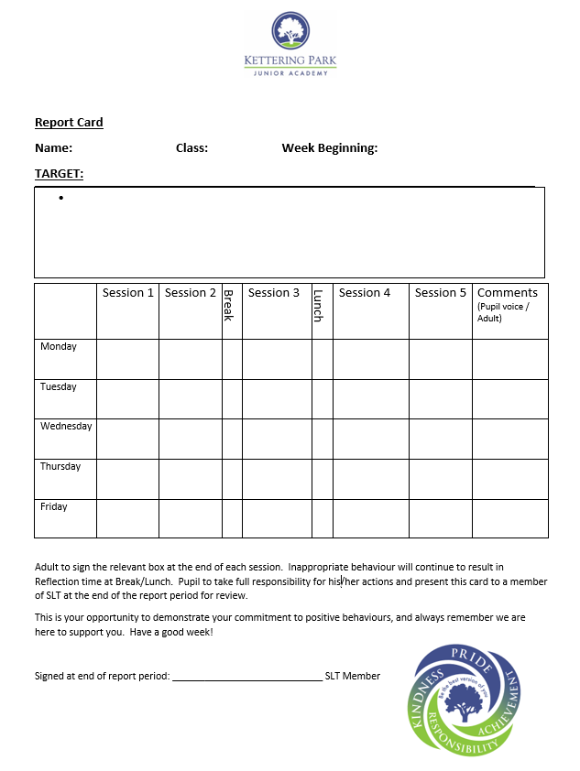

Appendix 6 – Example Behaviour Support Plan KPIA and KPJA:
This plan is written by the SENCO –alongside ………… class teacher – ……….., This plan will be shared with his teaching assistant – …….., the Head Teacher – and parents.
……….. has been displaying different levels of challenging behaviours, and this plan aims to address these challenging behaviours and identify the triggers for these and a response to the behaviour. During Year 1 so far….., Description of challenging behaviours displayed:
Explanation/ Notes/ Guidance
Challenging behaviour
Before the behaviour
Possible triggers
Early Warning signs
Response to the behaviour
What typically happens when these behaviours are displayed
Intervention to be provided:
 |  | Explanation / notes | Adults to be responsible
STEP ONE | Prevention and stress reduction | Structured timetable:  This is not an exhaustive list and other ideas may be used and adapted.  Scripted language:  Keep language short and structured – try not to use questions but commands or statements. E.g.  Behaviour chart:
STEP TWO | Replacement behaviour  Tools to use when challenging behaviours are starting | Safe space/time out  ……  Scripted language:  Keep language short and structured – try not to use questions but commands or statements. E.g. You need to…  Reminder of action/consequences:  ……
STEP THREE | Reinforcement | Restorative talk:  After an incident – the adult who has been involved with dealing with Dominic’s behaviour will talk with him following a restorative approach and focus on discussing feelings and ways forward.

Date plan agreed: Review date:
Parent: _______________________________
Teacher: _______________________________
Teaching Assistant: _______________________________
Head Teacher: _______________________________
SENCO: _______________________________

Appendix 7 - Dojo Rewards and Weightings

Category | Weighting
Helping Others | 1
On Task | 1
Participating | 1
Persistence | 1
Teamwork | 1
Effort | 1
Asking Questions | 1
Learning Independently | 1
Ready to Learn | 1
Being Creative | 1
Raised awareness of 1 set category | Max 3 points
Temporary category | Max 3 points
Headteacher Star | 5

Dojo Points | Reward
20 | An opportunity to change your dojo avatar
50 | An Dojo message home
100 | A choice of reward from a stipulated list that has been agreed with the class teacher  E.g. Sit with a friend for the afternoon or have IPad reward.
150 | A dojo message home
200 | A dojo certificate awarded.
250 | A choice of reward from a stipulated list that has been agreed with the class teacher  E.g. Sit with a friend for the afternoon or have IPad reward.
300 | End of term reward – Agreed with class teacher.

Dojo points and rewards will be reviewed half-termly.

Appendix 8 – Principles of Nurture
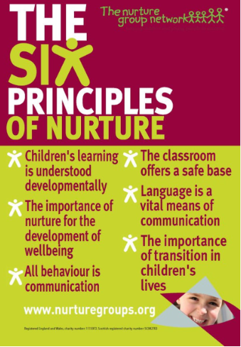

Appendix 9 - Progressive language for Zones of Regulation
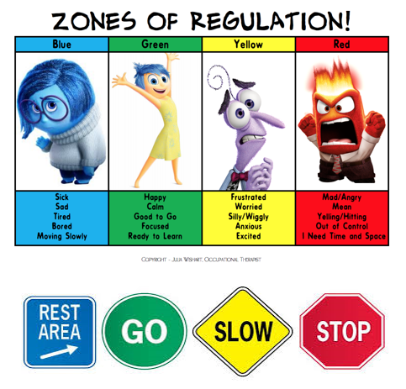
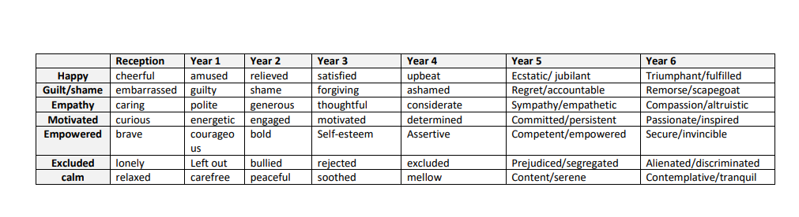

Appendix 10 – Behaviour cards
You have 5 minutes to improve your behaviour.   | You have 5 minutes to improve your behaviour.
You have 5 minutes to improve your behaviour. | You have 5 minutes to improve your behaviour.
You have 5 minutes to improve your behaviour. | You have 5 minutes to improve your behaviour.
You have 5 minutes to improve your behaviour. | You have 5 minutes to improve your behaviour.
You have 5 minutes to improve your behaviour. | You have 5 minutes to improve your behaviour.
Consequence card | Consequence card
Consequence card | Consequence card
Consequence card | Consequence card
Consequence card | Consequence card
Consequence card | Consequence card

