

Teaching, Learning and Curriculum Policy

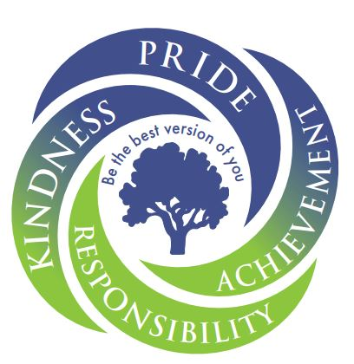
Document Title | Teaching, Learning and Curriculum Policy
Approved by: | KPJA LAC
Approval date: | September 2025
Review frequency: | Annually
Review date: | September 2026

At Kettering Park Junior Academy our vision is for children to be the best version of themselves.

As an academy we want our children to develop academically and personally becoming secure in their sense of self, ready to take their next step in the world, both within the academy and beyond. We care for the whole child, nurturing their sense of belonging and community as part of the Park family.

Our four core ‘PARK’ values are:
Pride
Achievement
Responsibility
Kindness

Our children are encouraged and supported to use these throughout their academic learning and social interactions every day.

Curriculum

At Kettering Park Junior Academy we believe that providing a broad and balanced curriculum enables children to be the best that they can be across all subjects. They build on and expand their existing substantive knowledge through a range of disciplinary lenses whilst finding their passions. We engage our children's curiosity about the world around them, providing opportunities for learners to ask questions and discuss their learning. We incorporate our PARK values of Pride, Achievement, Responsibility and Kindness across all aspects of our school life to ensure that when our children leave us, they are able to tackle the challenges ahead of them as resilient individuals who believe in themselves.

Our long term maps are based on the national curriculum and allow for coverage and progression across the school, building on previous substantive knowledge and subject disciplinary knowledge learnt in the Foundation stage and Key Stage 1. Content is carefully sequenced to support retention and understanding.
Most children will have the foundation knowledge required to access and meet the expected standard in lessons across the curriculum but some will need adaptations, scaffolding and support to do this, others will need opportunities to extend and deepen their learning (See Appendix 1). There may be some exceptions to this and they will be children who have been identified as working out of curriculum.

English

At Kettering Park Junior Academy, reading is placed at the heart of the school. It is our aim to engender a love of reading whilst teaching the vital comprehension disciplinary knowledge which enable children to unlock learning for life.
The children receive reading and writing lessons daily, covering all National Curriculum requirements for their age group. Whole class guided reading is focussed around our expert tips to develop knowledge of fundamental reading disciplinary knowledge. This is reinforced through coaching books and quizzes on our online platform - Oxford Reading Buddy - which they use as part of their home learning. Children also receive regular opportunities to apply their understanding to comprehension exercises, including daily DERIC starters.
Writing lessons are planned around the four main purposes of writing: to entertain, inform, persuade and discuss. We draw upon Jane Considine’s ‘The Write Stuff’ which breaks writing into small chunks and uses the ‘FANTASTICS’ to ensure children have high quality models, opportunities to participate in shared writing and engaging experiences upon which to base their compositions. Emphasis is placed on the writing process, with regular planning, writing and editing sequences. In addition, lessons with a specific grammar focus are taught within the context of writing units. Our discrete Read Write Inc spelling sessions, taught daily, investigate rules and patterns and allow children to regularly practise these.
Mathematics

At Kettering Park Junior Academy our aim is to provide rich opportunities for children to learn and love maths, ensuring that they will be making connections between their knowledge and the real world. By the end of Key Stage Two, children will leave our academy prepared for the next step in their mathematical education.

The adopt a mastery approach to the teaching of mathematics following the Power Maths White Rose scheme. This is underpinned by the five big ideas; coherence, representation and structure, mathematical thinking, fluency, and variation to help guide the children towards a deeper understanding within the subject. This builds on the same scheme used by our main KS1 feeder school. Power Maths is used to support and challenge all pupils and is built on the belief that everyone can learn maths successfully. In lessons concepts are broken down into small steps so that all children can build on their learning.
Students access a range of fluency, reasoning and problem-solving questions which are designed to support different needs and confidence levels, whilst also fostering a spirit of working and learning together. Through mathematical talk, children will develop the ability to articulate and discuss their thinking with an emphasis on explanations and justifications. It also encompasses the CPA approach to teaching mathematics (Concrete, Pictorial and Abstract) which is a system of learning that uses physical and visual aids to build a child’s understanding so that they can access the abstract. Using this approach, allows pupils to have a better understanding of the relationship between numbers and the real world, and therefore helps secure their understanding of the mathematical concept they are learning.

Teaching

At Kettering Park Junior Academy we aspire to have high quality, effective teaching across all classrooms to ensure that all children are provided with learning experiences that lead to a consistently high level of pupil achievement and attitude. We aim to provide lessons that inspire, motivate and encourage children to become independent learners, equipped with the knowledge needed to continue to learn effectively throughout their life. We promote positive learning behaviours following the academy’s behaviour policy to achieve this.

Our approach to teaching is based on Rosenshine’s key principles (see Appendix 2):

- Daily review
All of our lessons begin with a recap of prior learning relevant to the lesson opportunities to recall and practise previously learned substantive and disciplinary knowledge and to assess whether information is being retained.
- Present new material using small steps
We use an ‘I do, We do, You do’ style of teaching to introduce new learning in small steps.
- Ask questions
Teachers plan a range of open and closed questions, both to effectively check for understanding and to scaffold children’s learning. This makes use of paired and whole class discussion.
- Provide models
Through teacher modelling (I do) teachers use their subject expertise to provide children with worked examples of expected outcomes and high-quality work. This includes modelling high standards of written and spoken English along with good communication skills.
- Guide student practice
Through shared class, paired and guided group work (we do) children are supported to practice using new materials and knowledge. We encourage collaborative learning and opportunities for discussion in pairs and small groups.
- Check for student understanding
We use a range of assessment strategies both within and after lessons to provide relevant, clear and helpful information about the current knowledge of learners. This is used to provide meaningful feedback to help pupils to progress according to the Academy feedback policy.
- Obtain a high success rate
We aim to obtain a high success rate by maintaining high expectations of lesson outcomes and provide support and opportunities to achieve this.
- Provide scaffolds for difficult tasks
When planning we ensure there is an equal opportunity for all learners to access every lesson by adapting teaching strategies and resources to support and scaffold pupils to reach intended outcomes (See Appendix 1)
- Independent practice
Following modelled (I do) and guided (we do) work, children are provided with opportunities to practise and apply their new learning in a range of tasks.
- Weekly and monthly review
We aim to create a spiral curriculum that allows children to build on previous knowledge and make connections to new learning. Key concepts are presented repeatedly throughout the curriculum, to deepen their understanding but also support retention. Lessons begin with a review of the previous lesson/week’s and other relevant learning to support this.

Learning

We have high expectations for all children but do not limit them to these expectations as they will always have the potential to exceed these. We assume that the majority of children have the opportunity to meet or further the expected standards within their year group, regardless of previous attainment and experiences, and we provide scaffolding and support for children who may have barriers to their learning so that all children can leave KPJA will the knowledge to succeed.
To enable this we need to:
- Promote a love of learning through curious lessons
- Provide them with the knowledge and initiative to build on their own learning capacity so that they feel confident to take risks with their learning
- Allow them to apply substantive knowledge and subject disciplinary knowledge to different contexts for different purposes
- Enable opportunities which allow them to make informed choices about their learning
- Encourage a curious approach to learning by asking and responding to questions that help them make connections to their immediate, local, wider and international surroundings so that they can become active citizens within society
- Teach the knowledge needed to establish their own approach to embedding social, physical and mindful well-being so that they can support their own development as they grow
- Guide towards developing effective communication skills to enable them to make connections with others
- Create lessons that allow for active and enthusiastic learners who develop increased independence towards learning
- Consistently follow the behaviour policy to ensure appropriate learning behaviours are being displayed and maintained
- Have high expectations of presentation in all books
- Mark work in line with the feedback policy allowing for children to reflect on their own work or others work
At KPJA we recognise that it isn’t just staff members in school who play a part in the quality of education for our children but that parents and the local advisory committee (LAC) also play a role. We value the importance of the parent/carer in their child’s education and are committed to supporting parents and carers to be involved both at school and at home. Home school communication is an essential element in this process and we use Class dojo, Arbor, newsletters, assemblies, parents into school sessions and our family support worker to encourage parents and carers to take an active role.

The parents/carers will help to support their child’s learning by:

- Promoting positive relationships between all members of the school community
- Ensuring they attend school regularly and are punctual
- Supporting them in completing their homework activities
- Listening to their child read at least 5 times a week or for the more able readers encouraging independent reading
- Attending and contributing to parents evening meetings
- Communicating and working with the school to help meet their child’s needs
- Actively supporting the home-school agreement

The LAC at our school will support the quality of education by:

- Promoting positive relationships between the LAC and all members of the school community
- Meeting regularly to discuss the school’s needs
- Visiting the school to talk students about their learning experiences
- Visiting the school to talk with staff members and take part in learning walks
- Attending training and other related events

Planning, Monitoring and Assessing
We plan using planning powerpoints and all teaching notes and resources are on them. All year group planning is monitored regularly by the key stage lead and appropriate subject lead. They are responsible for monitoring whether planning is completed to a high standard and feedback and support is given as and when needed.
The quality of education is determined by triangulating lesson observations, book look findings and pupil progress data. Members of the leadership team visit lessons at any point in the school day and we have an open-door policy where this is encouraged and valued.
Regular assessments are made of pupils’ work in order to establish the level of attainment and to inform future planning. Formative assessment is used to guide the progress of individual pupils. It involves identifying each child’s progress in each area of the curriculum, determining what each child has learned and what therefore should be the next stage in his/her learning.

Summative assessment is carried out 3 times a year within core subjects across all year groups using teacher assessment and PiXL testing (previous SATs papers for Year 6). At the end of KS2, Year 6 take the end of Key Stage assessment which assesses the children against age-related expectations as set out by the National Curriculum. In non-core subjects end of unit assessments are carried out to assess children’s substantive knowledge and retention which then support and inform future planning.

Appendix 1 - Adapting Teaching and Learning

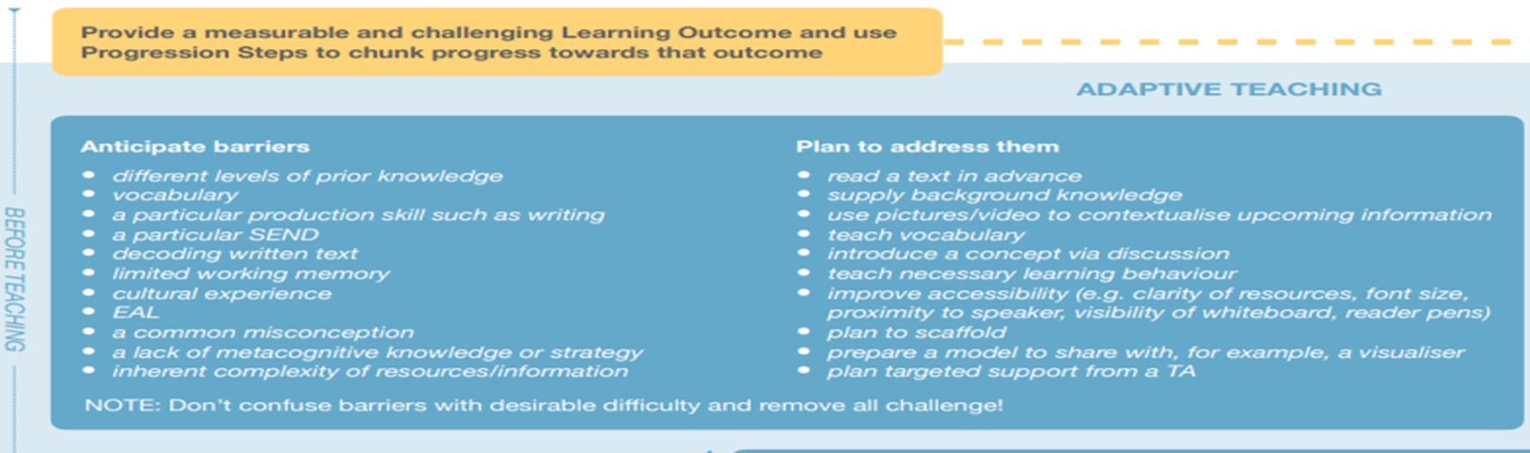

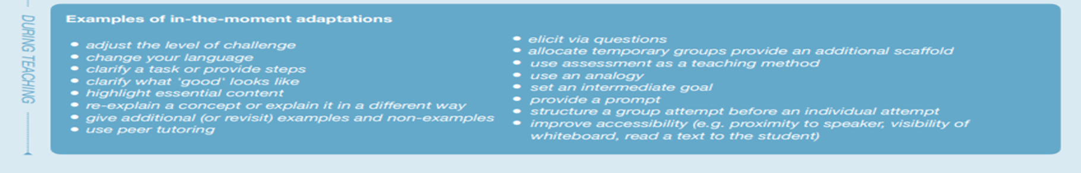

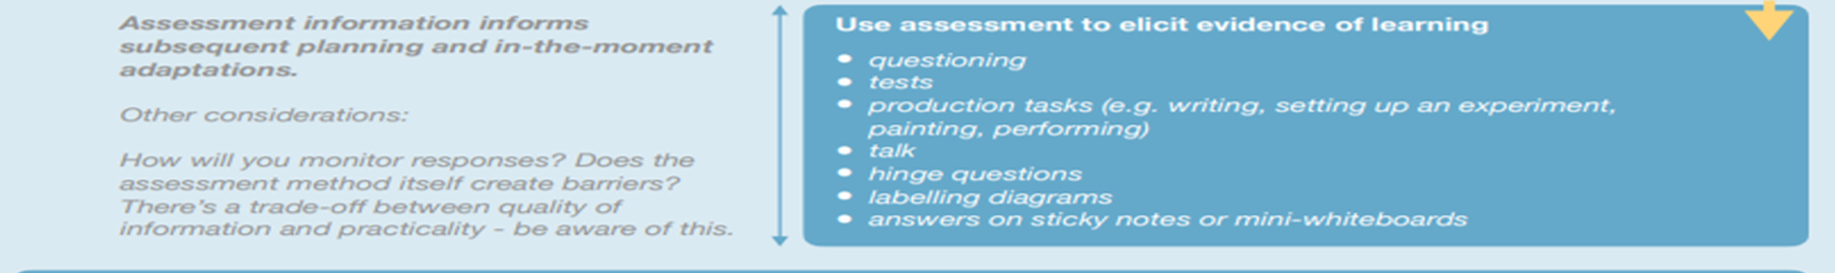

Appendix 2 – Rosenshine's key principles
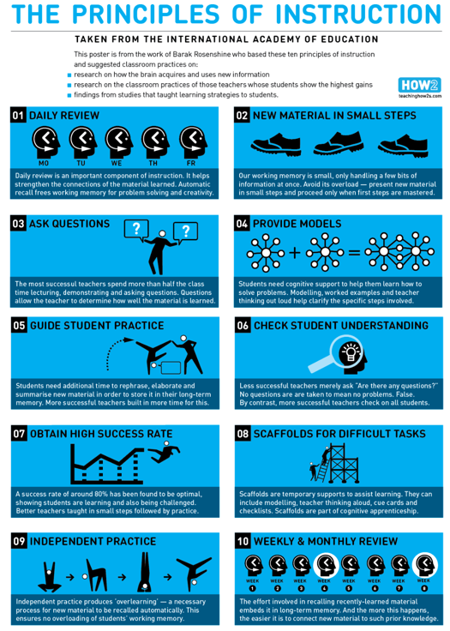

Appendix 3: Feedback Policy
Introduction
At Kettering Park Junior Academy we embed our ethos and values into everything we do. The principles of feedback contained within this policy are in line with our PARK values.

The overriding consideration is that the feedback is understood by the children.
Our policy is underpinned by research which suggests that providing feedback is one of the most effective ways of improving Students Learning (EEF and John Hattie). Studies show that feedback led to an improvement of 8 additional months’ progress over the course of a year.

What is Feedback?

Feedback is information given to the learner about the learner’s performance relative to learning goals or outcomes. It should aim to (and be capable of producing) improvement in students’ learning.

Feedback redirects or refocuses the learner’s actions to achieve a goal, by aligning effort and activity with an outcome. It can be about the output or outcome of the task the process of the task the student’s management of their learning or self-regulation, or about them as individuals (which tends to be the least effective).

Feedback is central to a teacher’s role. However, it is important to note that written feedback is only one form of feedback. “A conversation with the child about what they have done well and what they need to do to improve…makes a difference to learning (M Myatt 2013). Providing plenty of feedback during the lesson can be more appropriate and more immediate, which can improve the progress that the child makes.
Feedback can come from a teacher or someone taking a teaching role, or from peers.

Feedback processes

- Feedback delivered closest to the point of action is most effective and as such feedback and ‘live marking’ delivered in lessons is more effective than comments provided at a later date. When feedback is given then time must be given for children to act and reflect on it.
- Feedback is used to inform teachers planning and children’s learning.
- Feedback offers the children specific information on the extent to which they have met the lessons success criteria.
- Promote self-assessment, whereby the children recognise their difficulties, and are encouraged to accept guidance from others;
- Gauge the children's understanding, and identify and correct any misconceptions
- Where the child is not able to read and respond in the usual way, other arrangements for communication must be made;
- Written and verbal comments should be appropriate to the age and ability of the child.

Curiosity Questions/Teacher model/Success Criteria
Curiosity questions are used as titles in books to enable children to assess their understanding of substantive and subject disciplinary knowledge against the aim of the lesson. Success criteria set out what the children need to know and be able to do in order to be successful in the lesson. These are shared at an appropriate point during the lesson for children to refer to and may be modelled by the teacher.

Feedback Strategies
At KPJA we use a range of strategies to feedback to our students. We empower our teachers to decide the most appropriate form of feedback

- Verbal feedback (individual or whole class)
- Live marking
- Skimmed feedback
- Peer feedback
- Self-assessment

Children are expected to respond to all forms of feedback in purple pen to demonstrate that they have received and followed the advice given.

Verbal Feedback
Verbal feedback typically involves spoken comments from the teacher either to an individual group or class. It tends to be more immediate than written feedback and is given during or at the end of an activity. It may also be given at the beginning of the following lesson after the teacher has reviewed the work from the previous lesson.

Live marking
Immediate marking of the work by the teacher gives the child information on how to improve current or future work. This is done through an agreed set of marking codes (see skimmed marking).

Skimmed Feedback
Skimmed feedback will consist of the class teacher using codes or short written comments to support the child with areas to improve. This would support the verbal feedback given and help to focus on the area to develop.

What | Meaning
- Ticks | Correct or particularly good work
Pink highlighter | Work to correct or improve (not spellings/punctuation)
G 1:? | Guided work (significant support/ guidance given throughout) in a ratio of 1:?
SG 1:? | Some guidance (marked next to question/part of work where support was given) in a ratio of 1:?
_______ | Incorrectly spelt word underlined to correct. Word written by teacher for child to write x3 at end of work.
 | Grammatical error to correct
 | Missing word to insert
 | Missing or incorrect punctuation circled
// | New paragraph needed

Self-assessment
Students should be given the opportunity to assess their own work against the success criteria or correct answers making edits in purple pen. When self-assessing, children should follow the PARK approach:

Pause
Assess the work against the success criteria or correct answers
Respond to the assessment
Keep going!

Peer Feedback
Where peers are giving feedback, discussions should reflect the success criteria of the lesson and should be meaningful. To ensure this, teachers will need to spend some time modelling effective feedback to the students. Children’s response to peer feedback discussions should be completed in purple pen.

Cover Marking
Internal staff covering a session will be required to initial the work and detail support given as above, unless otherwise directed by the head teacher.

Monitoring the Feedback Policy:
Subject Leaders monitor feedback standards across the subject as part of their self-review. The Leadership Team include monitoring of feedback as part of their scrutiny of pupil work across the school. The Feedback Policy will be reviewed annually and shared with governors.

Dissemination:
This policy is shared with all staff as part of Kettering Park Junior Academy’s Policies Handbook. (Electronic copy on the shared area and hard copy in the staffroom folder).

