
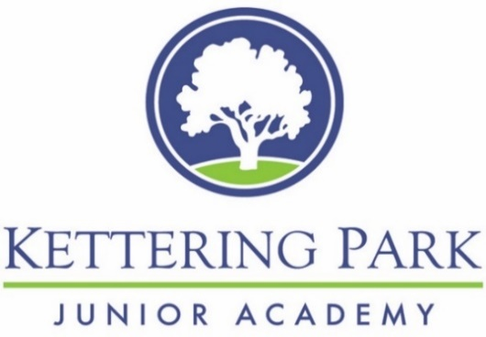
EDIT

Positive Relationships and Behaviour Policy

Document Title | Positive Relationships and Behaviour Policy
Approved by: | KPJA Governing Body
Approval Date: | September 2026
Review Frequency: | Annually
Review Date: | September 2027

KPJA Values and Ethos InMAT Values and Ethos
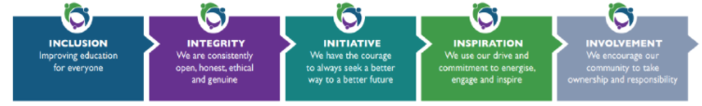
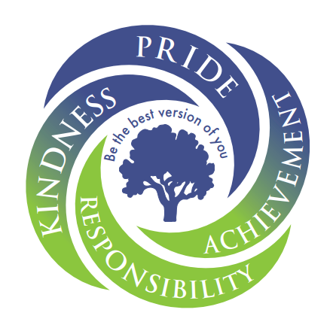

School Rules

Our School Values
At Kettering Park Juniors, we are guided by four core values:
Pride • Achievement • Responsibility • Kindness
These values shape the way we learn, interact with others and contribute to our school community. They help us create a positive, supportive and ambitious environment where everyone feels safe, valued and able to succeed.
Our ethos, "Be the best version of you", encourages all members of our school community to demonstrate our school values at all times. We believe every pupil can succeed and grow through positive behaviour, reflective learning, and a commitment to achieving their personal best.

What We Want to Achieve
The happiness and wellbeing of our pupils underpin everything we do at Kettering Park Juniors. We know that pupils achieve their best when they feel safe, respected, listened to and supported.
Our aim is to provide a clear, fair and consistent approach to behaviour that enables all pupils to learn, thrive and develop positive relationships. We believe that every pupil should be supported to develop the skills needed to succeed both in school and beyond.
These skills include:
- Building and maintaining positive relationships with peers and adults.
- Developing a positive outlook and resilience.
- Recognising and regulating their own emotions while understanding the emotions of others.
- Demonstrating positive learning behaviours that support their own progress and the success of others.
We recognise that behaviour is a form of communication and are committed to supporting pupils' emotional, social and personal development. Through our PSHE curriculum and wider school experiences, pupils are taught strategies to support their wellbeing, emotional regulation and problem-solving skills.
Staff consistently model respect, empathy and positive behaviours, helping pupils build strong relationships and develop the skills needed to become confident, responsible members of society. Our approach is further supported by the Six Principles of Nurture, which underpin our expectations for behaviour, relationships and learning.

Policy Statement
Kettering Park Juniors works collaboratively with schools across the Inspire Multi Academy Trust (InMAT) to promote high standards of behaviour and positive attitudes to learning.
We believe that all members of our school community should demonstrate respect, kindness, tolerance and consideration for others. Through consistent expectations and positive relationships, we encourage pupils to develop self-discipline, personal responsibility and respect for those around them.
The school maintains and reviews records of significant behaviour incidents in line with statutory guidance. Information is shared with the Local Academy Committee (LAC) and the Trust where appropriate to ensure effective monitoring and support.

Responsibilities

All Staff are responsible for:
- Implementing the behaviour policy consistently.
- Maintaining high expectations for behaviour.
- Promoting positive attitudes and relationships.
- Modelling respectful and positive behaviour at all times.
- Providing appropriate support and reasonable adjustments to meet the needs of individual pupils.
- Working in partnership with parents/carers and external agencies where appropriate.
- Recording behaviour incidents on Arbor and/or MyConcern, as required.
The Senior Leadership Team will ensure that this policy is implemented consistently across the school. They will support staff in responding to significant behaviour incidents and work closely with the Behaviour Lead to monitor behaviour patterns, evaluate the effectiveness of support strategies, and ensure that appropriate interventions are in place where needed.

The Behaviour Lead is responsible for:
- Monitoring behaviour trends across the school and using data to identify strengths and areas for development.
- Reviewing the effectiveness of behaviour systems, interventions and support strategies.
- Supporting staff in implementing the behaviour policy consistently.
- Working collaboratively with pupils, families and external agencies to address behavioural needs.
- Promoting restorative practice and the principles of nurture within the school's approach to behaviour.

Parents and carers are expected to:
- Support their child to follow the pupil code of conduct.
- Adhere to the parent code of conduct.
- Inform the school of any circumstances that may affect their child's behaviour or wellbeing.
- Raise any behavioural concerns with the class teacher promptly.
- Reinforce the school's expectations and recognise positive behaviour at home.

Pupils are expected to:
- Follow the school's rules and values.
- Behave in a calm, orderly and self-controlled manner.
- Show respect to all members of the school community.
- Take responsibility for their own learning and contribute to a positive learning environment for others.
- Move safely and quietly around the school.
- Treat school buildings, equipment and property with respect.
- Wear the correct uniform at all times.
- Accept consequences for their actions.
- Demonstrate positive learning behaviours.
- Report any concerns or unacceptable behaviour to a member of staff.
Our Approach to Behaviour
At Kettering Park Juniors, we take pride in ourselves and our school community. Our values and ethos are reflected in every aspect of school life. We believe that behaviour should be taught, supported and developed through positive relationships, high expectations and consistent routines.
Our approach is rooted in restorative practice. We support pupils to:
- Understand the impact of their choices on themselves and others.
- Take responsibility for their actions.
- Repair harm and rebuild relationships.
- Learn from mistakes and make positive choices in the future.
All behaviour responses, support strategies and consequences outlined in this policy are implemented in line with this restorative approach
Reasonable Adjustments and Pupil Support
At Kettering Park Juniors, we recognise that some pupils may require additional support to meet behavioural expectations. Before behaviour is escalated, staff will consider any underlying needs, barriers, or individual circumstances that may be influencing a pupil's behaviour.
In line with our duties under the Equality Act 2010, we will make reasonable adjustments where appropriate to ensure that behaviour expectations, support strategies, and responses are fair, proportionate, and inclusive.
The SENDCo and/or Wellbeing and Pastoral Lead will work with staff, families, and, where appropriate, external professionals to identify and understand any additional needs that may be contributing to a pupil's behaviour. This may include seeking advice from specialist teachers, educational psychologists, medical practitioners, or other relevant agencies.
Where additional needs are identified, the school will work collaboratively with families and external services to develop and review appropriate support plans, helping pupils to regulate their emotions, engage positively with learning, and achieve success in school.
Whilst inappropriate behaviour will not be condoned, relevant individual circumstances will be considered to ensure that responses are fair, supportive, and proportionate.

Creating a Climate for Positive Behaviour and Praise
At Kettering Park Juniors, we believe that positive relationships, high expectations and consistent recognition of success are key to creating a positive learning environment. We encourage pupils to take responsibility for their behaviour by reinforcing the values, attitudes and learning behaviours that contribute to a safe, respectful and successful school community.
Praise and positive recognition are used consistently to celebrate achievement, reinforce expected behaviours and encourage pupils to make positive choices. Pupils may be recognised individually or collectively through:
- Non-verbal and verbal praise (e.g. smiles, thumbs up and positive feedback)
- Positive and constructive feedback on work
- Stickers
- Celebration assemblies, Star of the Week awards and recognition of InMAT values
- Positive messages shared with parents/carers
- Post-it notes
- Class Dojo rewards
- Class reward time
- House and Dojo points
- Class collective rewards
We are committed to ensuring that every pupil feels valued, included and recognised as an important member of our school community. This is supported through our PSHE, RSE and No Outsiders curriculum, which promotes belonging, respect and acceptance.
Positive behaviour is built on strong relationships and mutual respect. We expect all members of the school community, including pupils, staff, parents/carers, governors and visitors, to treat one another with courtesy and respect. Staff model these expectations through their interactions and foster a welcoming environment by greeting pupils and encouraging positive communication throughout the school.

Promoting and Reinforcing Outstanding Behaviour
Communication and Shared Language
At Kettering Park Juniors, all adults are expected to adopt a relational approach that promotes positive behaviour through respectful communication, consistency and strong relationships.
Staff should address behaviour privately wherever possible and maintain pupils' dignity when discussing concerns. Behaviour conversations should focus on reflection, accountability and restoring positive relationships.
To promote a consistent and positive approach to behaviour, all adults will communicate with pupils in a calm, respectful and professional manner. Effective communication helps pupils understand expectations, develop self-regulation and feel supported in making positive choices.
When communicating with pupils, adults will:
- Speak respectfully and professionally at all times.
- Use a calm and courteous tone of voice.
- Avoid shouting or responding in ways that may escalate a situation.
- Respond to behaviour calmly and proportionately, avoiding unnecessary attention to inappropriate behaviour.
- Focus on the behaviour and its impact, rather than making personal judgements about the pupil.
- Use positive and supportive language when discussing behaviour.
- Model the attitudes and behaviours expected of pupils, including respect, responsibility, accountability and reflection.

Shared Language
To ensure consistency across the school, staff will use clear, respectful and non-confrontational language when responding to behaviour. Consistent language helps pupils understand expectations, supports emotional regulation and contributes to a calm, predictable learning environment.
Staff will use shared language to (Appendix X):
- Reinforce school values and expectations.
- Provide reminders and guidance.
- De-escalate situations.
- Encourage positive choices and behaviour.
- Support pupils to reflect on their actions and move forward positively.
Learning Behaviours, Routines and Transitions
Consistent routines help pupils feel safe, reduce uncertainty and maximise learning time. All adults are expected to establish and maintain calm, predictable routines that promote positive behaviour, support emotional regulation and minimise disruption.
To ensure a consistent approach across the school, Kettering Park Juniors follows a structured Behaviour Curriculum. This provides pupils with clear expectations, teaches positive learning behaviours and supports the development of independence, responsibility and self-regulation.
Through consistent routines, transitions and behaviour expectations, we create a positive learning environment where pupils can thrive academically, socially and emotionally.

Unacceptable Behaviour
Where a pupil's behaviour falls below the expected standard, staff will use a range of supportive strategies to help them return to positive behaviour and re-engage with learning. Responses will follow the school's 'Fix in Five' approach, providing a consistent and predictable framework for supporting pupils while maintaining high expectations.
Before moving through the stages, staff will consider whether any unmet needs, barriers or individual circumstances may be influencing the pupil's behaviour and will make reasonable adjustments or provide additional support where appropriate.
Stage | Classroom Response
1 | Classroom support strategies/Reminder
2 | Warning (Ready to Learn Checklist)
3 | Regulation Time (Classroom Regulation Area)
4 | Regulation Time (Alternative Classroom)
5 | 5-minute loss of break time (Low Level Behaviour recorded)
Where a pupil displays extreme behaviour, such as wilful damage to property or behaviour that significantly disrupts the learning environment, this is considered a red behaviour incident. An SOS card will be sent to alert the most appropriate member of staff, who will support the pupil with regulation and next steps.
Where necessary, the pupil may be temporarily removed from the classroom to enable them to regulate safely and successfully. When they return to class, a 'new lesson, new start' approach will be adopted to support a positive return to learning.
Where concerns persist over time, additional support, monitoring and intervention will be implemented to help the pupil achieve sustained success.

Behaviour Monitoring and Support
Behaviour Level | Trigger | Action
Low-Level Behaviour | An incident that negatively impacts learning or disrupts others | Reflection Sheet completed and restorative conversation held. Low-Level Behaviour Report completed.
Repeated Low-Level Behaviour | Three low-level incidents within one week | Parent/carer contact by the class teacher. Incident recorded on Arbor.
Sustained Low-Level Behaviour | Three further low-level incidents within a fortnight | Parent/carer contact by the class teacher. Behaviour Lead made aware Behaviour Support Plan implemented.
Extreme Behaviour | Isolated incident of extreme behaviour | Red Behaviour Incident. Parent/carer contacted by the Behaviour Lead. Behaviour Support Plan implemented.
Repeated Extreme Behaviour | Behaviour Support Plan targets are not met | Behaviour Report implemented monitored through Behaviour Lead and SLT.
Physical Aggression | Isolated incident of physical aggression | Red Behaviour Incident. Parent/carer contact by the class teacher.  Incident recorded on Arbor
Repeated Physical Aggression | Two incidents of physical aggression within a half term | Behaviour Report implemented monitored through Behaviour Lead and SLT.
Serious incidents may result in immediate escalation within the behaviour process, including suspension where appropriate. Equally, pupils who demonstrate sustained improvement may move to a lower level of support or exit the monitoring process altogether.

Post-Incident Procedures
Following a low-level behaviour incident, the member of staff involved will complete a Reflection Sheet (Appendix 2) with the pupil. The purpose of this conversation is to help the pupil reflect on their actions, understand the impact of their behaviour and identify positive strategies for the future. Reflection conversations should take place when the pupil is calm and ready to engage.
The following questions will be used to support discussion and reflection:
- What happened?
Give each person the opportunity to explain their perspective and work towards a resolution.
- How do you feel?
Support pupils in identifying and expressing their emotions, using the Zones of Regulation where appropriate.
- What could you do differently next time?
Help the pupil identify strategies to make positive choices and avoid similar situations in the future.
- What needs to happen to put things right?
Agree any actions needed to repair relationships and resolve the situation.
Repeated low-level behaviour incidents will be recorded on Arbor to ensure appropriate support and monitoring are in place. This enables staff and senior leaders to identify patterns, monitor concerns and implement additional support where required.
If a member of staff is unsure how to respond to a behaviour incident, or believes an alternative approach may be more appropriate, they should seek advice from a member of the Senior Leadership Team or the Wellbeing and Pastoral Lead before taking action. All decisions should be made in the best interests of the pupil and the wider school community.
Where appropriate, staff should also consult the SENDCo to ensure that any agreed reasonable adjustments for pupils with Special Educational Needs and Disabilities (SEND) are consistently implemented.

Extreme Behaviour Concerns
Some behaviours are of such a serious nature that they require an immediate response from the Behaviour Lead or a member of the Senior Leadership Team. In these circumstances, the usual behaviour stages may not be applied, and the incident may be escalated immediately.
Any response will take into account the individual circumstances, severity and impact of the incident. Appropriate consequences, support and follow-up actions will be determined on a case-by-case basis and communicated to the class teacher.
Examples of extreme behaviour may include:
- Physical aggression
- Verbal abuse
- Threatening behaviour
- Serious rudeness or defiance
- Significant disruption to learning
- Deliberate damage to property
- Persistent refusal to follow reasonable instructions
- Racist, homophobic or other discriminatory language
- Serious use of inappropriate language

Off-Site Behaviour
The school may apply consequences where a pupil's behaviour falls below expected standards while representing the school off-site, including during educational visits, sporting events or other school activities.
Any response will be proportionate to the circumstances of the incident and will be decided by the Headteacher or a designated senior leader.
Suspension and Internal Suspension
On occasion, the Headteacher may determine that a formal process should be implemented to temporarily remove a pupil from their usual learning environment. Such measures are only taken when other behaviour support strategies have not resulted in sustained improvement, or when an incident is of such seriousness that immediate action is required to ensure the safety and wellbeing of others.
In some circumstances, a pupil may receive an internal suspension. This means that the pupil remains in school but is removed from their usual class, peers, and activities for a specified period of time. During an internal suspension, the pupil will complete work in a separate supervised area and will have limited contact with other pupils. This provides an opportunity for the pupil to reflect on their behaviour whilst minimising disruption to the learning of others.
Where the seriousness of an incident warrants it, the Headteacher may issue a suspension from school (at home). This means that the pupil is not permitted to attend school for a specified period of time and must remain at home under parental supervision. Work may be provided for the pupil to complete during the suspension period to support their continued learning.
Both internal suspensions and suspensions from school are considered serious sanctions and will only be used when appropriate and proportionate to the circumstances.
Examples of behaviours that may result in an internal suspension or suspension from school include:
- Causing significant harm to another pupil, including emotional, physical, social, racist, sexual, verbal, or online harm.
- Premeditated physical assault a member of staff or another pupil.
- Deliberately causing significant or permanent damage to school buildings, property, or equipment.
- Persistent or serious behaviour that significantly disrupts the learning, safety, or wellbeing of others.
(The above list is not exhaustive.)
When an incident of exceptional seriousness occurs, all parties may require a short period to consider the most appropriate course of action and any support that may be required to prevent a recurrence.
Following a suspension from school, the pupil and their parent/carer will be invited to attend a reintegration meeting. During this meeting, the Headteacher, parent/carer, and pupil will discuss the incident, review any support that may be required, and agree clear expectations to help ensure a successful return to school and learning.
In the event of an exclusion Kettering Park Junior Academy will follow the guidelines set out by the government: https://www.gov.uk/school-discipline-exclusions/exclusions. Please also refer to the InMAT Suspension policy available on the KPJA Website.

The Use of Reasonable Force
Kettering Park Juniors is committed to maintaining a safe and supportive environment for all pupils and staff. In line with Department for Education (DfE) guidance, reasonable force may be used where necessary to prevent injury, serious disruption or damage to property.
Reasonable force refers to the minimum level of physical contact required to prevent harm, maintain safety or restore order. It may range from guiding a pupil away from a situation to more restrictive forms of physical intervention where there is an immediate risk of harm.
Control can involve passive or active physical contact, such as standing between pupils, blocking a pupil's path, or guiding a pupil to a safer location.
Restraint refers to physically holding a pupil to prevent them from causing harm to themselves or others. This will only be used when necessary and proportionate to the level of risk presented.

Who Can Use Reasonable Force?
All school staff have the legal authority to use reasonable force when it is necessary and appropriate to do so.
This power applies to staff employed by the school and may also extend to individuals who have been authorised by the Headteacher to be in charge of pupils, including volunteers and visitors supporting school activities.

When Can Reasonable Force Be Used?
Reasonable force may be used to prevent a pupil from:
- Causing injury to themselves or others.
- Committing an offence.
- Causing serious disruption to learning or school routines.
- Damaging property.
Wherever possible, staff will use de-escalation and other supportive strategies before considering physical intervention. However, in situations where there is an immediate risk of harm, reasonable force may be used without prior warning.

Principles for the Use of Reasonable Force
Any use of reasonable force must:
- Be lawful, reasonable, necessary and proportionate to the circumstances.
- Be used only when other appropriate strategies have been unsuccessful or when immediate action is required to maintain safety.
- Use the minimum force necessary for the shortest possible time.
- Preserve the dignity, safety and wellbeing of all those involved.
- Never be used as a punishment or solely to secure compliance.
- Be recorded promptly and accurately in accordance with school procedures.
- Be reported to parents/carers as soon as reasonably practicable.

Training and Recording
The school provides appropriate training for designated staff in de-escalation techniques and positive handling strategies. Following any incident involving reasonable force, a written record will be completed and reviewed by a member of the Senior Leadership Team. The circumstances of the incident, actions taken and outcomes will be documented in line with school procedures and statutory guidance.

Confiscation and Searching
To maintain a safe and orderly learning environment, prohibited, illegal or potentially harmful items may be confiscated from pupils.
Any prohibited items found in a pupil's possession will be dealt with in accordance with school procedures. Where appropriate, confiscated items will be returned to parents/carers. Illegal items will be passed to the Designated Safeguarding Lead (DSL) and, where necessary, other relevant authorities.
The school may also confiscate items that pose a risk to safety, wellbeing or the smooth running of the school. Decisions regarding the return of such items will be made by senior leaders in consultation with parents/carers where appropriate.
The searching, screening and confiscation of items will be carried out in line with current Department for Education (DfE) guidance. Staff may search a pupil or their possessions with the pupil's consent. Where consent is not given, a member of the Senior Leadership Team will determine any further action in accordance with statutory guidance and school procedures.
Wherever possible, searches should be conducted in the presence of another member of staff.

Appendices
- Legalisation and statutory requirements
- Positive phrasing
- Ready to Learn Checklist
- Reflection sheets (restorative conversation)
- Report card
- Behaviour/ Pastoral Support plan
- Dojo and Rewards
- Principles of Nurture
- Example of Zones of Regulation

Appendix 1. Legislation and statutory requirements
- This policy is based on advice from the Department for Education (DfE) on:
- Behaviour and discipline in schools
- Searching, screening and confiscation at school
- The Equality Act 2010
- Use of reasonable force in schools
- Supporting pupils with medical conditions at school
- It is also based on the special educational needs and disability (SEND) code of practice.
- In addition, this policy is based on:
- Schedule 1 of the Education (Independent School Standards) Regulations 2014; paragraph 7 outlines a school’s duty to safeguard and promote the welfare of pupils, paragraph 9 requires the school to have a written behaviour policy and paragraph 10 requires the school to have an anti-bullying strategy
- DfE guidance explaining that academies should publish their behaviour policy and anti-bullying strategy online

Appendix 2: Positive phrasing

Adults will focus on the expected behaviour rather than what pupils should avoid. This helps pupils understand what they need to do and supports successful choices.

- Instead of: ‘Don’t run!’
- Use: ‘In the hall we PARK walk’

- Instead of :'No talking!'
- Use: ‘When a peer is contributing, the expectation is that we listen carefully’

Reaffirmation of expectations

Adults will calmly restate the expected behaviour without entering into unnecessary debate.

- The expectation is __________________

This reinforces the behaviour we want to see and provides pupils with a clear opportunity to make a positive choice.

Positive Recognition

Adults will actively notice and reinforce positive behaviours.

- Well done _____________ for ___________

Specific praise helps pupils understand which behaviours are valued and encourages others to demonstrate the same expectations.

A collaborative approach
Adults will use inclusive language to reinforce shared responsibility and belonging.
- At Kettering Park, we expect __________
Using “we” communicates that expectations are shared by the whole school community.
Clarifying actions and consequence
Adults will use clear “if… then…” language to help pupils understand choices and outcomes.
- ‘If you___________ then ___________
This allows pupils to understand the connection between their actions and the consequences that follow.

Coregulation
When pupils are experiencing difficulty regulating their emotions or behaviour, adults will use calm, supportive language to help them regain control.
Adults will use the following sequence:
Pause
Create space and reduce demands to allow the pupil time to regulate.
“I can see you are __________.”
Acknowledge the pupil’s emotional state or behaviour without judgement.
“Let me help you.”
Offer support and reassurance.
“Follow me.”
Guide the pupil towards a calmer environment or next step.
Adults should repeat this sequence calmly, particularly the final three statements, until the pupil is able to regulate and engage positively with support and reflection.

Appendix 3: Ready to Learn Checklist

Appendix 4: Reflection Sheet

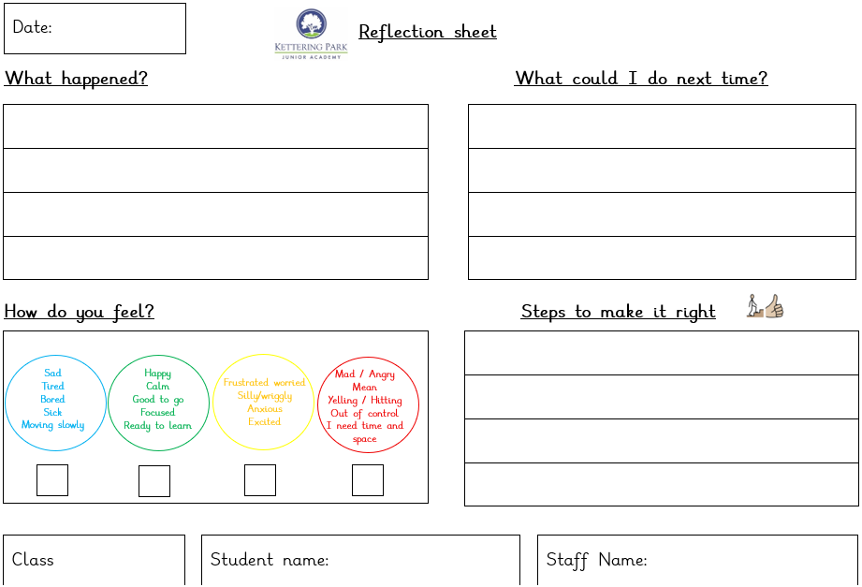

Appendix 5: Report card
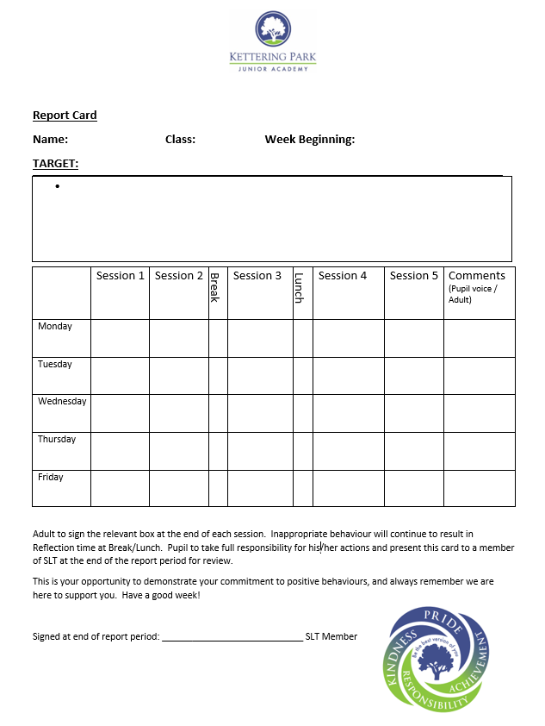

Appendix 6: Pastoral Support/Behaviour Plan

Appendix 7: Dojo Rewards and Weightings
Category | Weighting
Helping Others | 1
On Task | 1
Participating | 1
Persistence | 1
Teamwork | 1
Effort | 1
Asking Questions | 1
Learning Independently | 1
Ready to Learn | 1
Being Creative | 1
Raised awareness of 1 set category | Max 3 points
Temporary category | Max 3 points
Headteacher Star | 5

Dojo Points | Reward
20 | An opportunity to change your dojo avatar
50 | An Dojo message home
100 | A choice of reward from a stipulated list that has been agreed with the class teacher  E.g. Sit with a friend for the afternoon or have IPad reward.
150 | A dojo message home
200 | A dojo certificate awarded.
250 | A choice of reward from a stipulated list that has been agreed with the class teacher  E.g. Sit with a friend for the afternoon or have IPad reward.
300 | End of term reward – Agreed with class teacher.

Dojo points and rewards will be reviewed half-termly.
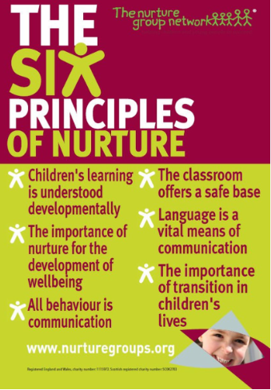
Appendix 8: Principles of Nurture

Appendix 9: Progressive language for Zones of Regulation


