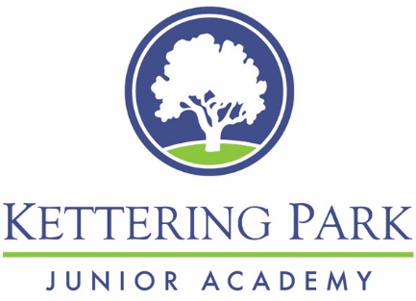 |  | STAFF
Training
SLT – Mental Health Leader in school
All staff MINDED unlimited access mental health awareness training every year
Team Building & Communication
All staff events – Summer BBQ ……..
Refurbished staff area with complimentary refreshments
Weekly all staff briefings
Support
Regular staff survey to inform planning
24/7 mental health app inc counselling support

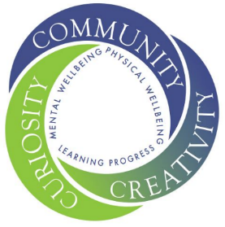  Wellbeing at KPJA  Our school ethos commits to develop and support the mental wellbeing of all of our children and staff.  CONTACT  Wellbeing Mentor  Mrs Parkes  Behaviour & Inclusion Assistant  ??? |  | students
Universal
Whole school events – Mental Health Awareness Week
Wellbeing Ambassadors - Self-Regulation stations - Calm down areas outside of class - Wellbeing garden - Zones of Regulation taught across the school - Worry boxes in every class - Wellbeing resources - Wellbeing tracker - FSW for all families - mindfulness and co-regulation - Access to Wellbeing Team throughout the day

Targeted
Welcome Booklet and support for new students
Small group interventions - social skills - arts & crafts - gardening - emotional literacy
1:1 programmes - bereavement support - drawing & talking

Specialist
Referrals to outside agencies when required for additional support for children
 |  | network support
School links

KPJA is part of the Northamptonshire Healthy School Programme. This provides us with regular training, access to resources, a bank of further information and advice plus regular network meetings and opportunities to learn from shared practice.

